1. Create an HTML form with two text fields — First Name and Last Name — and a Submit button.

When the user submits the form, validate the following using JavaScript (triggered by the onsubmit attribute):

* Both fields must not be empty.
* Each field must have at least 2 characters.
* If validation fails, prevent form submission and display an alert message.

1. Create an HTML form with a single text field for entering a Username.  
   As the user types, the characters should automatically convert to uppercase using JavaScript and the addEventListener method.
2. Create an HTML form with a single text field to accept a User’s Age for a community membership check.

Using JavaScript, display a dynamic message below the input field as follows:

* If the age is less than 40:  
  → Show "To be a part of the community, you need to at least 40".
* If the age is between 40 and 50 (inclusive):  
  → Show "You are the youngsters of this community".
* If the age is greater than 50:  
  → Show "Top level members of the group" in red text.

1. Think of this as the layout of a webpage, drawn on graph paper where each grid square is 10px × 10px. Use the grid to place and measure elements precisely.

On this webpage, the background has grid lines spaced 10px apart. Using the grid as a guide:

Draw a 300px × 200px container box (aligned to the grid).

Inside it, place a smaller box labeled “Bottom Right” that is positioned 10px from the bottom and 10px from the right of the container.

Show the dimensions of both boxes in pixels and state how many grid squares wide and high each box is.

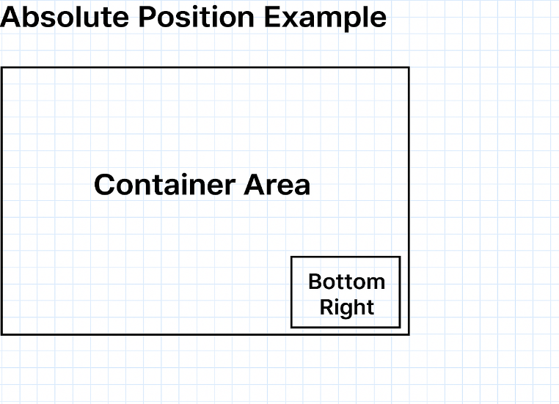

1. Create an HTML page with a button labeled "Change Background".  
   When the button is clicked, the webpage’s background color should change to a random color. Use addEventListener to listen for the click event. Generate a random color each time the button is clicked. Apply the color to the document.body background.

Example:

First click → Background becomes light blue.

Second click → Background becomes pale yellow.

Third click → Background becomes lavender.

1. What will be the output of the following code if you the “Double Values” button first and second click the “Remove Last” Button and third click the “Add Number” button.  
     
   <!DOCTYPE html>

<html lang="en">

<head>

<meta charset="UTF-8" />

<meta name="viewport" content="width=device-width, initial-scale=1" />

<title>Practice</title>

</head>

<body>

<p>Current Array: <span id="arrayDisplay">[1, 2, 3, 4, 5]</span></p>

<button id="addNumberBtn">Add Number</button>

<button id="removeLastBtn">Remove Last</button>

<button id="doubleValuesBtn">Double Values</button>

<button id="resetBtn">Reset Array</button>

<script>

let arr = [1, 2, 3, 4, 5];

const display = document.getElementById('arrayDisplay');

function updateDisplay() {

display.textContent = JSON.stringify(arr);

}

function addNumber() {

let nextNumber = arr.length ? arr[arr.length - 1] + 1 : 1;

arr.push(nextNumber);

updateDisplay();

}

function removeLast() {

if (arr.length > 0) {

arr.pop();

updateDisplay();

} else {

alert("Array is already empty!");

}

}

function doubleValues() {

arr = arr.map(num => num \* 2);

updateDisplay();

}

function resetArray() {

arr = [1, 2, 3, 4, 5];

updateDisplay();

}

document.getElementById('addNumberBtn').addEventListener('click', addNumber);

document.getElementById('removeLastBtn').addEventListener('click', removeLast);

document.getElementById('doubleValuesBtn').addEventListener('click', doubleValues);

document.getElementById('resetBtn').addEventListener('click', resetArray);

updateDisplay();

</script>

</body>

</html>

1. What will the output of the following code in console if you type 9 characters in the password field?  
     
   <!DOCTYPE html>

<html lang="en">

<head>

<meta charset="UTF-8" />

<meta name="viewport" content="width=device-width, initial-scale=1" />

<title>Password Validation</title>

</head>

<body>

<h2>Password Validation</h2>

<form>

<label for="password">Enter Password:</label><br />

<input type="password" id="password" name="password" autocomplete="off" />

</form>

<script>

const passwordInput = document.getElementById('password');

passwordInput.addEventListener('input', () => {

const val = passwordInput.value;

if (val.length > 0 && val.length < 8) {

console.log('Password must be 8 characters long');

}

if (val.length > 12) {

console.log('Will you be able to remember it?');

}

if (val.length > 16) {

console.log('Remember long passwords are too hard to remember');

}

});

</script>

</body>

</html>